***Departure station : Nakhodka-Vostochnaya (exp.) DVZHD. Destination station : stations of the railroad network of RZhD OJSC. Cargo carrier: RZhD OJSC***

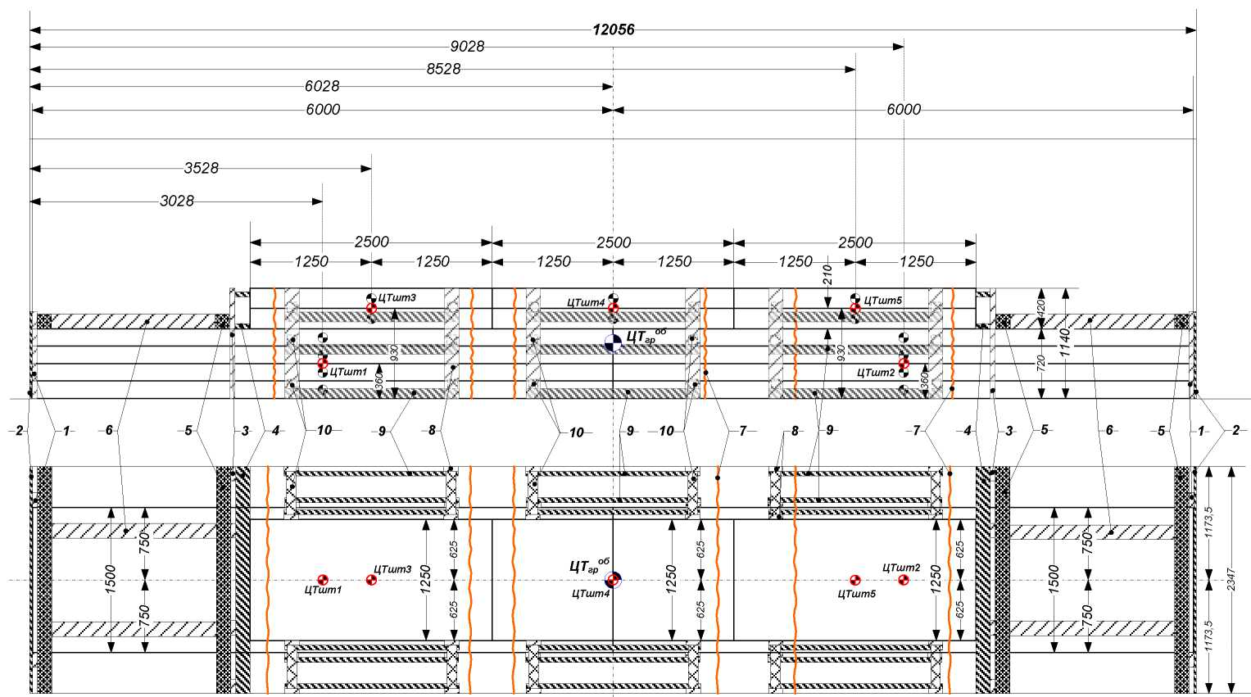

***Approved by:***

***Head of the container freight station  
Vostochnaya***

Stevedoring Company LLC

***Е. M. Schulzhenko***

***« » 2021.***

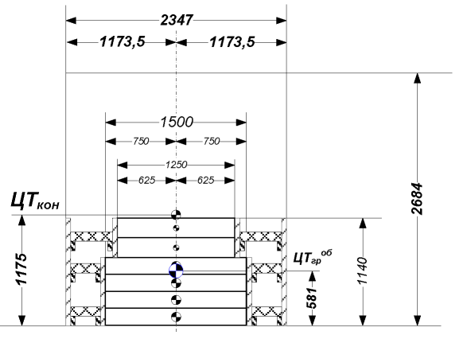

*In the view from the end of the board positions 1, 2, 3 and 4  
 are not conditionally shown*

***Agreed by:***

***Head of Nakhodka-Vostochnaya station.  
 DVZhD. RZhD OJSC***

***Moiseev E.V.***

***« » 2021***

Specification of fastening elements and materials used

Notice: ЦТ – Load Center

|  |  |  |  |  |  |  |  |  |  |  |  |
| --- | --- | --- | --- | --- | --- | --- | --- | --- | --- | --- | --- |
| *Item*  *of stack* | *Cargo name* | *Qty*  *.* | *Total weight, t.* | *Overall dimensions of the cargo* | | | *Coordinates of the load center, mm* | | | *Load stability coefficient in* | |
| *Length, mm* | *Width, mm* | *Height, mm* | *In length, mm* | *In width, mm* | *In height, mm* | *Longitudinal direction* | *Transverse direction* |
|  | *Transportation block with metal* | *4* | *7.184* | *6000* | *1500* | *720* | *3000+3000* | *750+750* | *360* | *<1,25* | *<1,25* |
| *2* | *Transportation block with metal* | *4* | *7.183* | *6000* | *1500* | *720* | *3000+3000* | *750+750* | *360* | *<1,25* | *<1,25* |
| *3* | *Transportation block with metal* | *2* | *3.036* | *2500* | *1250* | *420* | *1250+1250* | *625+625* | *210* | *<1,25* | *<1,25* |
| *4* | *Transportation block with metal* | *2* | *3.035* | *2500* | *1250* | *420* | *1250+1250* | *625+625* | *210* | *<1,25* | *<1,25* |
| *5* | *Transportation block with metal* | *2* | *3.042* | *2500* | *1250* | *420* | *1250+1250* | *625+625* | *210* | *<1,25* | *<1,25* |

ETSNG code 324116 - "Rolled ferrous metal products, not indexed by name"

Choosing a container:

1. *Use large-capacity containers of type 1AA with a nominal gross weight of 30.48 tons with internal dimensions: length - 12056mm, width - 2347mm, height - 2684mm. Containers must comply with GOST R 53350-2009 (ISO 668:1995), GOST R 51876-2008 (ISO 1496-1:1990), GOST 20259-80 (ISO 1496-1).*
2. *The cargo for transportation must be prepared in such a way as to ensure the safety of train traffic, safety of cargo and container in the process of transportation. The shipper shall be responsible: for the specified dimensions, weight and location of the load center of each unit of cargo; for the correct indication of the ETSNG code (classes of transport rates), for securing the cargo in the transportation block; for the reliability of the blocks' structure. The fastening elements shall be prepared for transportation and installed in accordance with section 1, p. 4 of the Specifications.*
3. *The cargo in the container must be placed according to the drawing and in such a way that the projection of the load center of each load lags behind the projection of the longitudinal and transverse symmetry planes of the container at the distances indicated in the drawing. The end wall and doors of the container must be enclosed with a shield made of vertical boards (item 1) and horizontal boards (item 2). Boards (item 2) must be attached to the boards (item 1) with nails (item 11), two at each joint. The ends of the boards (item 2) must fit into the cavities of the corrugations of the side walls of the container. The cargo must be loaded with two stacks of 6000 mm in length in the lower tier and three stacks of 2500 mm in length in the upper tier, according to the drawing. The upper blocks with the cargo in the stack No. 3, 4, 5 must be fastened from the longitudinal shift with shields made of vertical boards (item 3) and horizontal boards (item 4). Boards (item 3) must be attached to the boards (item 4) with nails (item 11), two at each joint. The ends of the boards (item 4) must fit into the cavities of the corrugations of the side walls of the container. Also, the upper tier with cargo must be secured with frames made of dead stop rails (hurters) (item 5) and strut rails (stretchers) (item 6). Dead stop rails (hurters) and strut rails (stretchers) (items 5 and 6) must be fastened together with cramp iron (braces) (12), two at each joint. From the transverse shift, all cargo units must be secured with vertical boards (item 8), connecting boards (item 9) and strut rails (stretchers) (item 10). All the fastening elements must be fastened together with nails (item 11), two at each joint. Stack No. 3, No. 4, No. 5 from the shift must be secured with strapping (item 7) of wire with a diameter of 6 mm in 2 threads.*
4. *The FREIGHT FORWARDER shall be responsible to the Shipper for the reliability and suitability of the package.*
5. *Used literature: Specifications (ЦМ-943) dated 27.05.2003 section 1 cl. 6, 10. para. 12. p. 1, 2, 3*

|  |  |  |  |  |  |  |  |  |  |  |  |
| --- | --- | --- | --- | --- | --- | --- | --- | --- | --- | --- | --- |
| *TOTAL* | | | | | |  |  | *1.521* | | *0.92* |  |
|  |  | | | | |  |  |  | |  |  |
|  |  | | | | |  |  |  | |  |  |
|  |  | | | | |  |  |  | |  |  |
| *12* | *Cramp iron (brace) GOST 103* | | | | | *D=6-8 mm, I=150 mm* | *16 pcs.* |  | | *0.002* |  |
| *11* | *Nails GOST 283* | | | | | *D=5 mm, I=120 mm* | *368 pcs.* |  | | *0.015* |  |
| *10* | *Strut rail (stretcher) (pine, spruce) GOST 8486* | | | | | *100х100х400\** | *36 pcs.* | *0.144* | | *0.086* | *4* |
| *9* | *Connecting board (pine, spruce) GOST 8486* | | | | | *50х100х1800\** | *36 pcs.* | *0.324* | | *0.194* | *4* |
| *8* | *Vertical board (pine, spruce) GOST 8486* | | | | | *50х150х420-1150\** | *36 pcs.* | *0.27* | | *0.142* |  |
| *7* | *Strapping (steel, wire) GOST 3282* | | | | | *D=6 mm, in 2 threads* | *6 pcs.* |  | | *0.015* |  |
| *6* | *Strut rail (stretcher) (pine, spruce) GOST 8486* | | | | | *150х150х1700\** | *4 pcs.* | *0.153* | | *0.092* |  |
| *5* | *Dead stop rail (hurter) (pine, spruce) GOST 8486* | | | | | *150х150х2420\** | *4 pcs.* | *0.216* | | *0.13* |  |
| *4* | *Horizontal board (pine, spruce) GOST 8486* | | | | | *50х150х2420\** | *4 pcs.* | *0.072* | | *0.044* |  |
| *3* | *Vertical board (pine, spruce) GOST 8486* | | | | | *50х150х450-1150\** | *8 pcs.* | *0.099* | | *0.054* | *4* |
| *2* | *Horizontal board (pine, spruce) GOST 8486* | | | | | *25*х150х2420\** | *12 pcs.* | *0.216* | | *0.13* | *4* |
| *1* | *Vertical board (pine, spruce) GOST 8486* | | | | | *50х150х900* | *4 pcs.* | *0.027* | | *0.016* |  |
| *Item*  *No.* | *Name* | | | | | *Dimensions* | *Qty*  *.* | *Volume, m3* | | *Weight*  *(tons)* | *Qty* |
|  | | *Full name* | *Date* | *Signature* | *Placement and fastening of metal in transportation blocks in a universal high-capacity container of 1AA type* | | | | | | |
| *Executed by:* | | *Gurkovskaya I.A.* | *23.07.21* | */signature/* |
| *Inspected by:* | |  |  |  | *Total weight, tons* | | *scale* | | *Drawing* | | |
| *\*- specify dimensions on site* | | | | | *23,48 m - cargo*  *0,92 m - fastening 24,4 m - total weight* | | *1:50* | | *29721ВТ* | | |